Social Media – How and Why Football Clubs Should Take Notice
- Published on March 9, 2016

Marie Binet

Senior Account Manager - Sport & Entertainment at Publicis Media
We all know social media is a big deal. Every day we see a new article highlighting the importance of social platforms and how crucial it is for rights holders and sponsors to embrace and develop them. The growth of online fan communities, as well as the increasing need for fans to interact with their sports team on a daily basis, has led to the creation of a new sports marketing strategy where “Engagement” is king.
The UK currently boasts 36m social network users, with a staggering, yet not unexpected, 95% of the 18-24 population using one platform or another. Bearing in mind this is the same 18-24 population who are turning to on demand TV and installing ad blockers in droves. They’re notorious for being hard to reach with traditional media, so you can understand the huge potential social networks hold for football & rugby clubs, not to mention the brands involved with said clubs.
You would think it would be an easy equation for clubs. Unique stories, loyal fans, and the power of live sport able to deliver millions of impressions with a simple hashtag. On paper, it seems a no brainer for clubs to be including their social media platforms in their sponsorship treasure chests. However what’s not so clear is how to turn this huge potential and reach into cold hard cash. With a few exceptions, most rights holders (clubs) are lacking the knowledge and advice needed to gain extra value for their sponsors and turn their social media platforms into profit churners.
In terms of considering social media as an integral part of their asset portfolio, its early days for football clubs in the UK, with perimeter boards, shirt and the more typical assets remaining the main focus. But the benefits of social media are clear. There are no limitations to inventory, no geographic boundaries, unique opportunities to target specific audiences, and the chance to deliver what all self-respecting sport involved brands want: fan ENGAGEMENT! With tonnes of content shared everyday by clubs, there is definitely room for more sponsor exposure. The shirt sponsors will automatically have incremental value delivered by player and team pictures shared on the platform, but what if the club was to take more control over this and select the pictures that showed the entire sponsor logo at the right angle to ensure it’s fully visible? It would deliver more value to their sponsor and strengthens the argument for renewal, which is exactly what commercial teams and clients are looking for.
It could be using the best pictures, maybe embedding logos in others, or having new assets like “player of the month” sponsored on social media, there’s heaps of possibilities. Having done some evaluation work for Norwich City, I spent many long hours on their social media platforms, and they are definitely doing something right in terms of driving up sponsor value. On Norwich’s Facebook page, team line ups are sponsored by Coral – nothing complicated, just a logo overlay on the picture – but very valuable in terms of fan exposure.
A main hurdle for rights holders is measurement, as without it, sponsors will likely turn their heads. When it comes to social media measurement the challenge is to make it part of the overall sponsorship reporting, which is usually based on the media value delivered by the asset. Using the same methodology for each platform is key, as we can compare their efficiency and understand which assets are driving the value.
Norwich City Instagram and Facebook: A good example of using owned social media to give club partners additional exposure
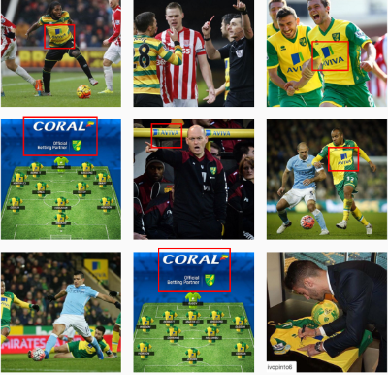
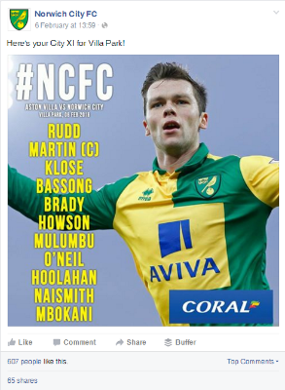

In all of the evaluation projects Stadia Solutions run for clubs, we always look to put a value on social media, and as we know the strength of clubs is their loyal fan base, we base this on the amount of engagements a post is likely to get on each platform. We then use an average CPE (Cost Per Engagement), by social network, to establish the value of a post. This method can also take into account the strengths of each social network.
Social media measurement continues to improve as we learn more about it. We now employ new software which is able to track brand logos on social networks, including pictures and video content, in the same way other software counts the amount of time brands are on screen during a TV broadcast. This allows us to give a shirt sponsor the value delivered by Facebook, Twitter, Instagram and Youtube. For a lower league club and their shirt sponsors, who do not have the huge TV exposure of the EPL, we have seen engagement levels from 50 to 10,000+ a day without specific sponsor content management. So just imagine the value (and revenue) a fully managed social media plan could deliver…

